Himalaya Public school
Syllabus 2025 - 26
Class 12th Sub. Mathematics
Month. Chapter's
April 1. Relations and Functions 2. Inverse Trigonometric Functions
May. 3. Matrices. 4. Determinants
June Holidays
July 5. Continuity and Differentiability. 6. Application of Derivatives
August 7. Integrals. 8. Applications of Integrals
9. Differential Equations
September 10. Vectors
October Exams
November 11. Three Dimensional Geometry. 12. Linear Programming
13. Probability
December Revision
January Revision
February Revision
March Exams Class 11th and 12th Sub. Mathematics

Pre - Board or Final Exam M. M. 80

Section : A

Mcqs 18 × 1 = 18

Assertion Reason based question 2 × 1 = 2

Section : B

Very short answer type questions 5 × 2 = 10

Section : C

Short answer type questions 6 × 3 = 18

Section : D

Very short answer type questions 4 × 5 = 20

Section : E

Source based/case based/passage based questions 3 × 4 = 12

Class 11th and 12th Sub. Mathematics

Unit Test M. M. 30

Section : A

Mcqs 8 × 1 = 8

Section : B

Short answer type questions 5 × 2 = 10

Section : C

Long answer type questions 4 × 3 = 12
Himalaya Public school

Syllabus 2025 - 26

Class 12th Sub. Mathematics

Exam Chapter's

Unit Test 1

1. Relations and Functions 2. Inverse Trigonometric Functions

3. Matrices.

Unit Test 2

4. Determinants 5. Continuity and Differentiability

6. Application of Derivatives

Pre - Board Exam 1

7. Integrals. 8. Applications of Integrals

9. Differential Equations 10. Vectors

With all syllabus of Unit Test 1 and Unit Test 2

Pre - Board Exam 2

11. Three Dimensional Geometry.

12. Linear Programming 13. Probability

With all syllabus of Pre - Board 1
Class 12
Sub chemistry
Syllabus

April
Ch .Solutions
Ch .Haloalkanes and Haloarenes(half)

May
Ch.Haloalkanes and Haloarenes (half)
Ch .Amines

June
Summer break

July
Ch. Alcohol,Phenol and Ethers
Ch. Aldehyde, ketone and carboxylic acids

August
Ch.Coordination Compounds
Ch.Electrochemistry

September
Ch.d and f block elements
Ch. Chemical kinetics

October
Exam

November
Ch .Biomolecules
Revision

December
Revision

January
Revision

February
Exam

Periodic test (P1) Syllabus May Month
Ch.Solutions
Ch.Haloalkanes and Haloarenes

Periodic test (P2) Syllabus August
Ch.Amines
Ch.Alcohol,Phenol,Ethers
Ch.Aldehyde ,Ketone and Carboxylic acid

Month October pre board (I)
Chapter 1 to Chapter 7

Month December pre board (II)
All syllabus

Paper pattern Periodic test (T.M 30)
Sec A (10)
M.c.q 1×8=8
Assertion reason 1×2=2

Sec B (10)
Short question answer 2×5=10

Sec C (10)
Long question answer 5×2=10

Paper style for exam

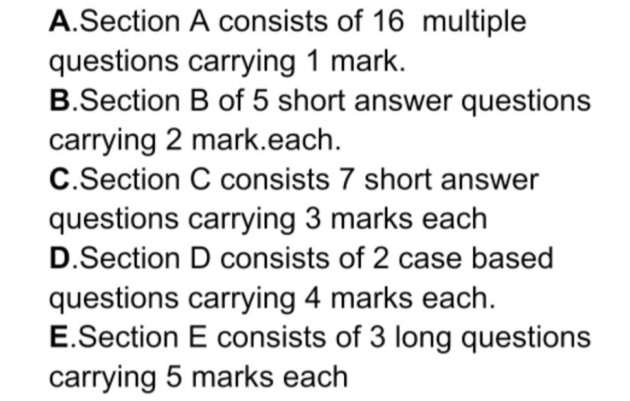

Himalaya Public Sen .Sec School Ghanauri kalan Class 12^{thMed} / ^{Non} ^{-Med} Subject : Physics
Month April :-
Chapter :1 Electric Charges and field
Chapter 2 : Electrostatic Potential and Capacitance Month May :-
Chapter 3 current Electricity Chapter 4 Magnetic Effect of current Month June :-
Holidays
Month July :- Chapter 5 Magnetism
Chapter 6 Electromagnetic Induction Month August :-
Chapter 7 Alternating current and electrical machines Chapter 8 Electromagnetic waves
Month September :- Chapter 9 Ray optics Chapter 10 Wave optics Month October:-
Exams
Month November:-
Chapter 11 Dual nature of Radiation and matter Chapter 12 Atoms and Nuclei
Month December :- Chapter 13 Nuclei
Chapter 14 Semiconductors Electronics material

Month January :- Revision
Periodic Test Syllabus :-
Periodic Test Syllabus P1 For Month May Chapter 1 :Electric Charges and field
Chapter 2: Electrostatic potential and capacitance Periodic Test Syllabus P2 For Month August Chapter 3:Current Electricity
Chapter 4: Magnetic Effect of Current Chapter 5: magnetism
Pre -Board Syllabus For Month October Chapter 1 To Chapter 10
Pre -Board Syllabus For Month December All Chapters
Paper pattern periodic Test :- Total marks :30
Section A
Multiple Choice questions ( 1×10 = 10 ) Section B
Short Question -Answers ( 2×5 = 10 ) Section c
Long Question -Answers ( 5×2 = 10)
Paper pattern physics For Pre -board Total Marks :70
1)) There are 33 questions in all. All questions are compulsory.
- This question paper has five sections: Section A, Section B, Section C, Section D and Section E.
- All the sections are compulsory.
- Section A contains sixteen questions, twelve MCQ and four Assertion Reasoning based of 1mark each, Section B contains five questions of two marks each, Section C contains

seven questions of three marks each, Section D contains two case study-based questions of four marks each and Section E contains three long answer questions of five marks each.
- There is no overall choice. However, an internal choice has been provided in one question

Session-2025-26
Class-+2 'Medical'
Subject- Biology

April:- UNIT-VI
chapter-1 Sexual Reproduction flowering plant
Chapter 2 Human Reproduction [ist Half]

May: UNIT-VI

Chapter-2: Human Reproduction [2nd Half']
Chapter-3:- Reproductive health

June:-
Holidays

July-VII-Unit

Chapter 4:- Principle of inheritance and variation
Chapter 5:- Molecular Basis of inheritance
Chapter 6: Evolution

August: Unit-VIII

chapter 7:- human health c
and diseases.
chapter 9: Microbes in Human welfare
Chapter 11 Biotechnology Principle and processes

September Unit-IX

chapter 12 Biotechonology and Application
UNIT-X
chapter-12 Organisms and populations
chapter -13 Ecosystem
October
Exams
November
UNIT X
Chapter 14 Biodiversity and it's conversation
December
Revision
January
Revision
February
Revision
March
Final Eexamination

Paper Pattern of Periodic Test

Section-A
10 one mank Questions 10×1 = 10

Section-B
5 two mark Questions 5 × 2 = 10

Section-C
2 five marked Questions 5× 2 = 10
Periodic test I syllabus
chapter-1 Sexual Reproduction flowering plant
Chapter 2 Human Reproduction [ist Half]

Periodic test II syllabus
Chapter-2: Human Reproduction [2nd Half']
Chapter-3:- Reproductive health
Chapter 4:- Principle of inheritance and variation

Pre board I Syllabus

chapter-1 Sexual Reproduction flowering plant
Chapter 2 Human Reproduction
Chapter-3:- Reproductive health
Chapter 4:- Principle of inheritance and variation
Chapter 5:- Molecular Basis of inheritance
Chapter 6: Evolution
chapter 7:- human health and diseases.
chapter 9: Microbes in Human welfare
Chapter 11 Biotechnology Principle and processes
chapter 12 Biotechonology and Application

Pre board II Syllabus
All Syllabus

Pre board exam pattern
(i) All questions are compulsory.
(ii) The question paper has five sections and 33 questions.
(iii) Section-A has 16 questions of 1 mark each,
Section-B has 5 questions of 2 marks each;
Section-C has 7 questions of 3 marks each;
Section-D has 2 case-based questions of 4 marks each; and
Section-E has 3 questions of 5 marks each.
(iv) There is no overall choice. However, internal choices have been provided in some questions. A student has to attempt only one of the alternatives in such questions.
(v) Wherever necessary, neat and properly labelled diagrams should be drawn.

